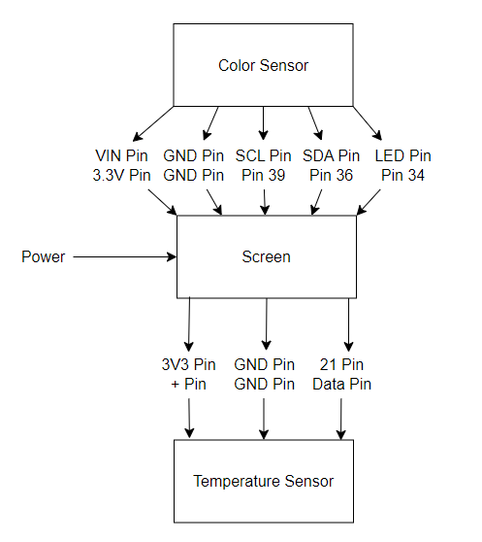

**Color Sensor**

VIN Pin

GND Pin

SCL Pin

SDA Pin

LED Pin

**Screen**

3.3V Pin

GND Pin

Pin 39 IO39

Pin 36 IO36

Pin 34 IO34

3V3 Pin 3V3

GND Pin GND

Pin 21 IO21

**Temp Sensor**

+ Pin

GND Pin

Data Pin

